2.a

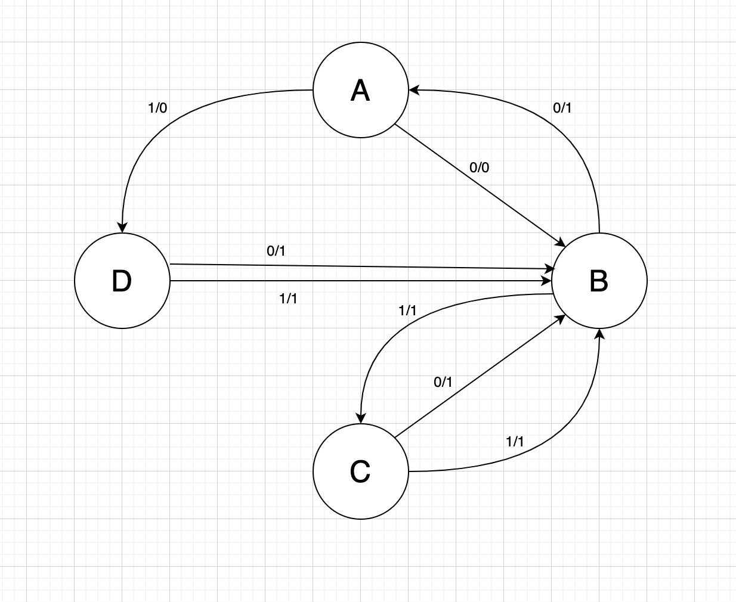

1. b

|  |  |  |  |  |
| --- | --- | --- | --- | --- |
| Test Case | 1 | 2 | 3 | 4 |
| Start State | A | A | A | A |
| Input | 0 | 0 | 1 | 1 |
| Expected Output | 0 | 0 | 0 | 0 |
| Next State | B | B | D | D |
| Input | 0 | 1 | 0 | 1 |
| Expected Output | 1 | 1 | 1 | 1 |
| Finish State | A | C | B | B |
| Test Coverage item | 1 | 2 | 3 | 4 |